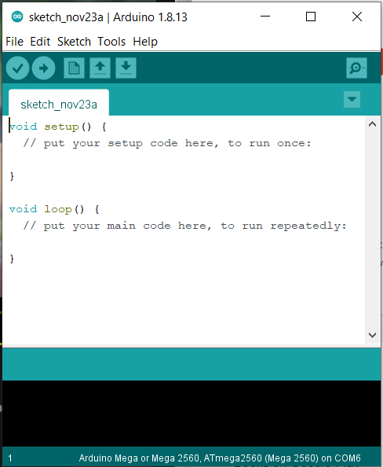

output

Board name and port

Sketch

Upload to I/O board

Verify